
Department of Artificial Intelligence and Data Science
QUESTION BANK FOR IV Sem (Term: May-August 2023)
Algorithms Laboratory (ADL46/AIL46)
I.A. Marks: 50 Exam Hours: 03
Credits: 0:0:1 Exam Marks: 50
Note:
1) For the questions in (a) that is related to asymptotic bounds program should be written and for the rest algorithm should be written.
2) Programs can be written or implemented using C / C++/ Java programming language.
3) The built-in modules should not be used for implementation (except time module and random module)
Sl.No | Questions | CO Mapping
 | - Given f(n)= 7n+5, Write a program to prove that f(n)= O(n) and find the n₀ value. Plot a graph for f(n) and c*g(n) where c is a constant and for varying n values (10 to 30).  - Given a set of men and women design and implement Gale- Shapeley algorithm to determine the stable set of marriages among them. Comment on the efficiency and the time complexity of the same.  Assumptions:  Men propose first according to their preference list.  Women can choose a better partner based on the preference.  Men’s preference list Women’s preference list  A V W X B W V X C V W X V A B C W B C A X C A B | CO1
 | - Given f(n)= 3n²+4n+3, Write a program to prove that f(n)= Ω(n) and find the n₀ value. Plot a graph for f(n) and c*g(n) where c is a constant and for varying n values (10 to 30).  - A GPS navigation system needs an approach to discover the reachable areas in a given geographical region from a given source area. Design and implement an algorithm to find which nodes can be reached from a given source node for the following graph. Comment on the efficiency and the time complexity of the same.  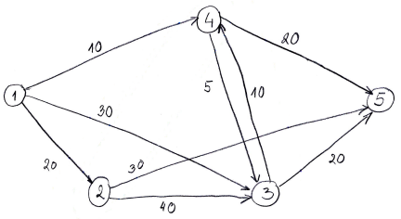 | CO1
 | - Given f(n)= 7n²+7n+5, Write a program to prove that f(n)= θ(n²) and find the n₀ value. Plot a graph for f(n), c₁*g(n)and c₂*g(n) where c₁, c₂is a constant and for varying n values (10 to 30).  - Design and implement merge sort algorithm that takes random number input and displays the execution time required. State the design strategy used and time complexity of the same. | CO2
 | - Given f(n)= 4n+3, Write a program to prove that f(n)= O(n) and find the n₀ value. Plot a graph for f(n) and c*g(n) where c is a constant and for varying n values (10 to 30).  - Three users in an online music portal listen to a playlist of 8 songs that are numbered from 1 to 8 in a random order. Each user needs to be recommended to another user playlist’s order that has minimum number of inversions. Design and implement an algorithm to determine the number of inversions. State the design strategy used and time complexity of the same. | CO2
 | - Given f(n)= 2n+3n+5, Write a program to prove that f(n)= Ω(n) and find the n₀ value. Plot a graph for f(n) and c*g(n) where c is a constant and for varying n values (10 to 30).  - In a database of numbers there is a table of unsorted numbers. The database admin now wants to sort these numbers using an approach wherein a pivot element is selected for sorting. At certain point, the first half elements are less than the pivot and right half elements are greater than the pivot. Design and implement an algorithm to solve it using random numbers and also display the execution time.  State the design strategy used and time complexity of the same. | CO2
 | - Given f(n)= 8n2+3n+3, Write a program to prove that f(n)= O(n2) and find the n0 value. Plot a graph for f(n) and c*g(n) where c is a constant and for varying n values (10 to 30).  - A truck driver is given a set of locations to be covered with their distances by a company. The company strictly orders that truck should be started from a particular location.  - Design and implement an algorithm that gives a greedy solution to the truck driver’s problem and display the shortest path for a given source location to all other locations. State the design strategy used and time complexity of the same.  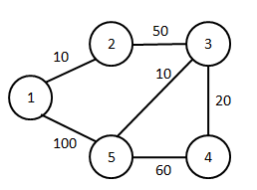 | CO3
 | - Given f(n)= 8n2+3n+3, Write a program to prove that f(n)= Ω(n) and find the n0 value. Plot a graph for f(n) and c*g(n) where c is a constant and for varying n values (10 to 30).  - A car driver is given a set of locations to be covered with their distances by a company. Now the company gives a privilege for the car driver to start at any arbitrary location. But, the condition is the route chosen by the driver should be minimum i.e. the total cost of the entire driving should be minimum.  Design and implement an algorithm that gives a greedy solution to the car driver and display the minimum cost achieved. State the design strategy used and time complexity of the same.  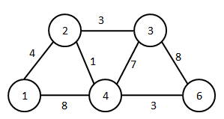 | CO3
 | - Given f(n)= 6n2+2n+2, Write a program to prove that f(n)= O(n2) and find the n0 value. Plot a graph for f(n) and c*g(n) where c is a constant and for varying n values (10 to 30).  - A phone company wants to lay lines for communication in a city. Different amounts are charged for connecting between a pair of cities.  Design and implement a greedy solution such that it forms a spanning tree with minimum cost. State the design strategy used and time complexity of the same.  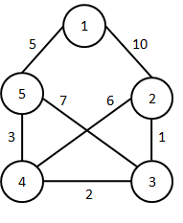 | CO3
 | - Given f(n)= 4n2+3n+5, Write a program to prove that f(n)= θ(n2) and find the n0 value. Plot a graph for f(n), c1*g(n)and c2*g(n) where c1, c2is a constant and for varying n values (10 to 30).  - Alia is planning for a trekking expedition with a backpack that can hold 7kg. She needs to select the most valuable items from the following list that can be accommodated within the backpack.  Design and implement an algorithm that displays the most valuable items that can be carried by him using Dynamic programming principles. State the design strategy used and time complexity of the same.  Items Weight Value  1 3 10  2 5 4  3 6 9  4 2 11 | CO3
 | - Given f(n)= 5n2+6n+3, Write a program to prove that f(n)= θ(n2) and find the n0 value. Plot a graph for f(n), c1*g(n)and c2*g(n) where c1, c2is a constant and for varying n values (10 to 30).  - A drama venue needs to be allocated for different drama school requests such that maximum profit is obtained for the company owning the drama venue. The requests are shown in the table with start–time, finish-time and the amount affordable by the drama school.  - Design and implement an algorithm such that maximum profit is obtained for the company owning the drama venue using Dynamic programming principles. State the design strategy used and time complexity of the same.  Drama School Start- time Finish- time Value  1 1 2 100  2 2 5 200  3 3 6 300  4 4 8 400  5 5 9 500  6 6 10 100 | CO3
 | - Given f(n)= 8n2+3n+3, Write a program to prove that f(n)= Ω(n) and find the n0 value. Plot a graph for f(n) and c*g(n) where c is a constant and for varying n values (10 to 30).  - Design and implement Bellman ford algorithm to find the shortest path from a given source to all other nodes using dynamic programming. State the design strategy used and time complexity of the same.  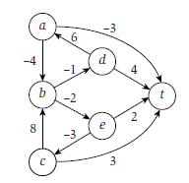 | CO3
 | - Given f(n)= 3n2+4n+3, Write a program to prove that f(n)= Ω(n) and find the n0 value. Plot a graph for f(n) and c*g(n) where c is a constant and for varying n values (10 to 30).  - Design and implement an algorithm for Travelling salesman problem using Branch and bound technique.  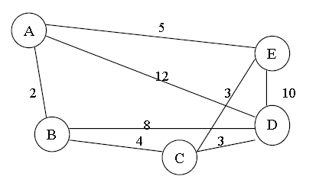 | CO3

Marks Distribution:

Conduction and Result | Write-Up (8) | Execution (35) | Viva/Demo | Change of Program | Total
Part – a | 4 | 15 | 7 | -10 Marks | 50 Marks
Part – b | 4 | 20

